## Extension Descriptions

Online discussion channel of communication allows the tender members and the supplier to communicate through the ERP application with no need for using mail.

### Basic Business Needs

Online Discussion provides you with the features you need to satisfy the following basic business needs. You will be able to address the following:

1. Allows Buyer and Suppliers to communicate together through ERP.
2. Allows supplier to send their clarifications to buyer and get answers to their clarifications
3. Online Discussion Reduces time and effort

### Major Features

#### Allow approval for online discussion

In administration page the admin has the option to create AME structure in the ERP and assign the AME to specific tender phase ex: clarification to suppliers in bidding phase could be different from technical phase

#### Forward messages to another user in the collaboration team of the tender

#### Add user from collaboration team in CC as mail

#### Add attachments to the message

#### In case meeting management is activated the admin has the option to allow the committee to approve the clarifications

#### The supplier cannot review the message sent from whom

The message and notification should not include the name of the sender, the organization name should be placed in the **from** column in the notification and message

### Assumptions

This design assumes that the following statements are true:

1. User is included in the tender collaboration team

### Design

1. Administration Page

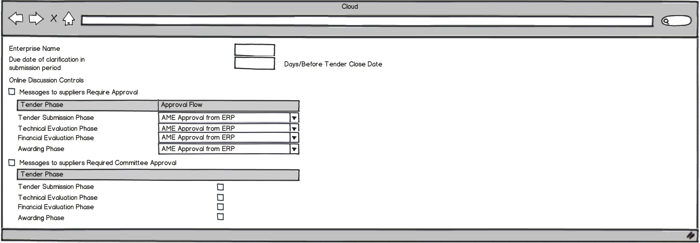

### Assumptions

1. Approval flow will be modified to be only one displayed field holding the value of AME transaction type as a fixed query condition

(e.g.) SELECT TransactionTypeEO.TRANSACTION_TYPE_ID

FROM apps.AME_CALLING_APPS_VL TransactionTypeEO,

apps.Fnd_application_vl fav

WHERE SYSDATE BETWEEN TransactionTypeEO.start_date

AND NVL (TransactionTypeEO.end_date - 1 / 86400,

SYSDATE)

AND TransactionTypeEO.Fnd_application_id = fav.application_id

AND UPPER (fav.Application_name) = 'SOURCING'

AND TransactionTypeEO.TRANSACTION_TYPE_ID = 'SEND_ONLINE_DISC'

1. The region related to the online discussion controls will be shown only if the Messages to supplier require approval check box is checked
2. Adding tender phases check boxes also to the online discussion controls to flag which phase it will require approval.
3. Add Allow members to send to suppliers check box (allow any one in collaboration team to send a message to suppliers).
4. Add Tender phases check boxes to allow members to send to suppliers only in the designated phase.
5. Supplier Submits Clarification
6. First Page

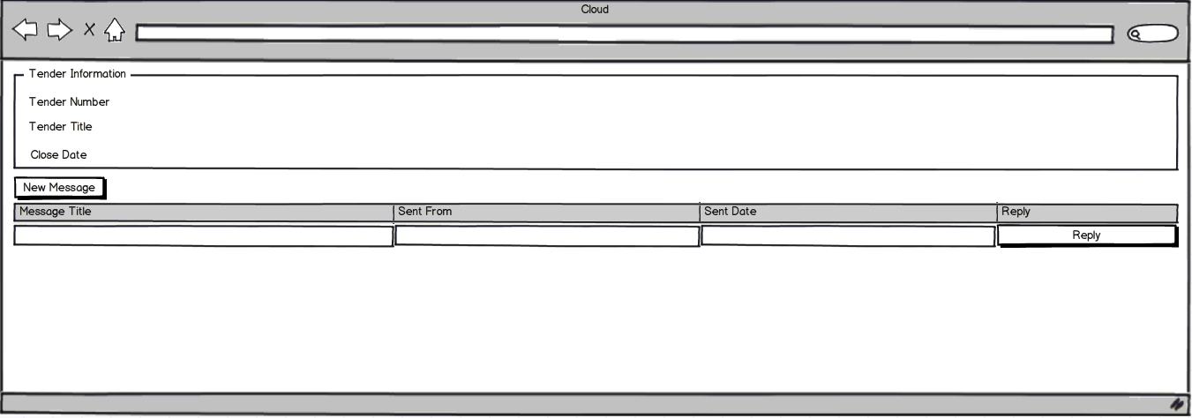

### Assumptions

1. The search page will get only the tenders for which the supplier is invited or paid its fees
2. The search results table will show all received and new messages
3. The search criteria will be by subject and body, not by tender.
4. Message Creation Page

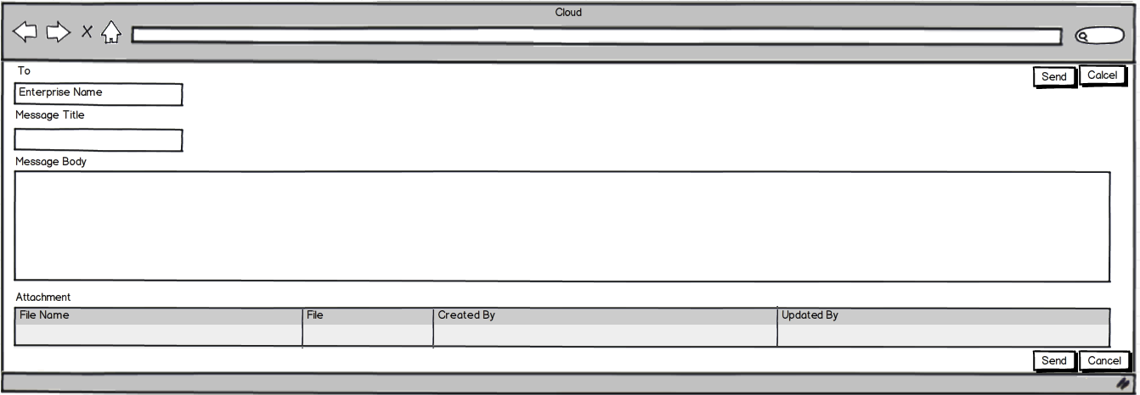

### Assumptions

1. When the supplier sends the message it will be sent to the creator of the tender
2. Buyer Pages
3. Review Message Page

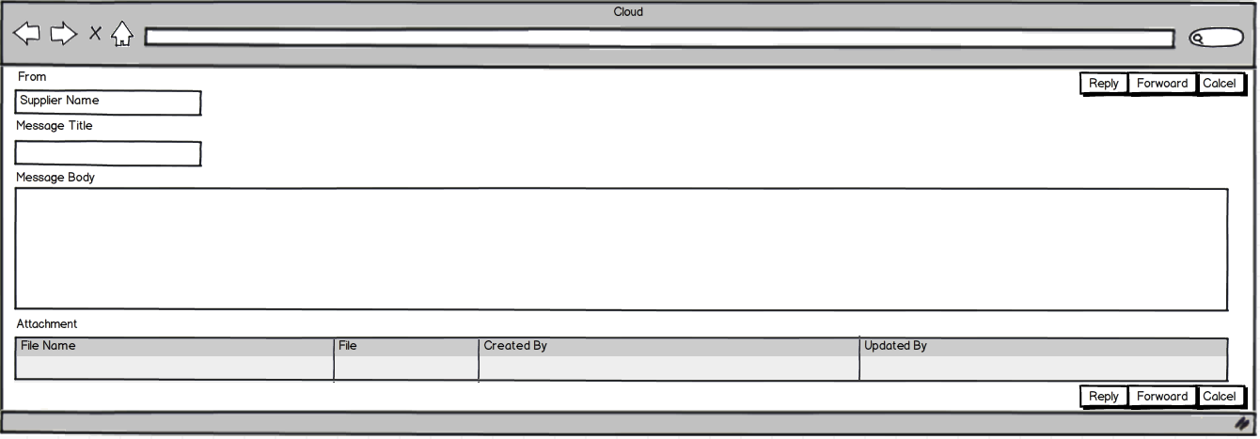

1. Reply Page

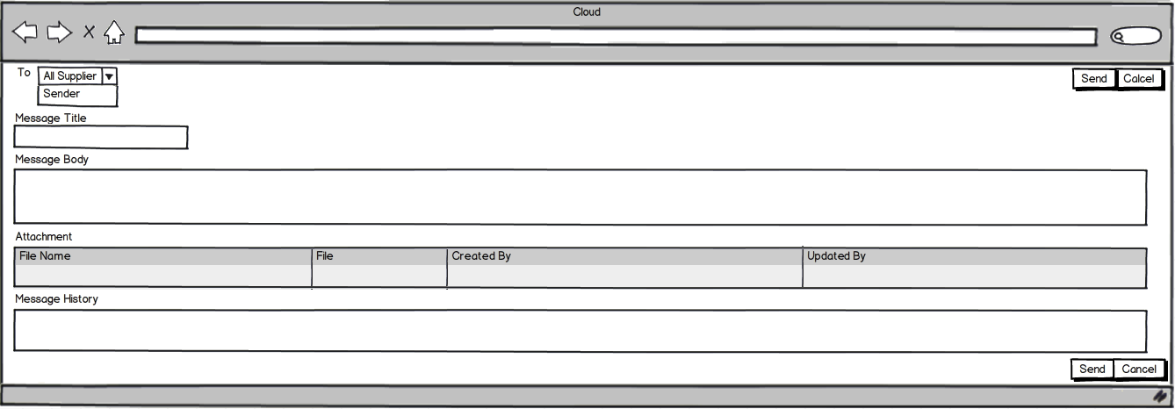

### Assumptions

1. Adding a CC field in the reply to supplier page.
2. Add internal list to get all collaboration team and external list to get the suppliers in case of creating new message to enable the creator to send the message to internal or external recipient
3. External list option only displayed if Allow members to send to suppliers check box is checked if the creator is a member in the collaboration team, if the creator is a buyer the option always enabled

1. Notifications



### Path